Directed Forgetting in Associative Memory: Dissociating Item and Associative Impairment
Jonathon Whitlock¹
Judy Yi-Chieh Chiu¹
Lili Sahakyan^{1, 2}

1. Department of Psychology, University of Illinois at Urbana-Champaign
2. Beckman Institute for Advanced Science and Technology

Correspondence concerning this article should be addressed to Jonathon Whitlock, Department of Psychology, University of Illinois at Urbana-Champaign, 603 E. Daniel St., Champaign, Illinois 61820. E-mail: Jsw6@illinois.edu
Abstract
We report three item-method directed forgetting (DF) studies to evaluate whether DF impairs primarily item memory, or whether it also impairs associative memory. The current studies employed a modified associative recognition paradigm that allowed disentangling item impairment from associative impairment in DF. Participants studied scene-object pairings, followed by DF cues (item-method), and at test were presented with a previously studied scene along with three objects, one of which was studied with that scene (target), whereas the remaining two objects were studied with different scenes (lures). Experiment 1 employed an associative encoding orienting task, and DF impairment was observed only when the Forget targets were paired with Forget lures within the test display; however, DF was eliminated when the Forget targets were paired with Remember lures, possibly due to a recall-to-reject strategy. Experiment 2 employed an object-focused orienting task that downplayed the encoding of associative information. The results revealed the opposite of Experiment 1, with significant DF when the Forget targets were paired with Remember lures, and no DF when the lures and the target came from the same memory instruction. Experiment 3 employed the same orienting task as Experiment 1, but testing employed a sequential procedure, where item recognition was assessed first, followed by associative recognition test. Conditionalizing associative recognition on item recognition outcomes confirmed that DF impairment of associative memory can be obtained despite retained memory for Forget-cued objects. Overall, the results provide strong support for the impairment of associative memory by DF.

Keywords: directed forgetting, item-method, associative recognition

Directed Forgetting of Associative Information
To most people, remembering is a successful outcome of memory, while forgetting is a failure of memory, or a nuisance that needs to be avoided. Contrary to lay beliefs, however, forgetting has been shown to serve a positive function, something that benefits rather than hinders the learning process (Bjork, 2011). It is not always necessary to retain all information, and sometimes we need to let go of information that may be outdated, wrong, or painful to remember. For example, hotel room numbers are likely to be forgotten once we check out, and old email passwords are likely to be forgotten when they are updated, potentially improving memory by offloading of irrelevant information. Finally, we may feel a need to downregulate emotionally painful or traumatic memories. These examples illustrate that sometimes we implicitly or explicitly evoke a need to forget certain information. In the laboratory, control over forgetting has been studied using the Think/No-Think paradigm (Anderson & Green, 2001), or the Directed Forgetting (DF) paradigm (Bjork, LaBerge, & LeGrand, 1968). The current study employs the DF paradigm and it investigates whether DF impairs information that accompanies the event one is trying to forget, such as contextual or associative information.
The DF paradigm has item-method and list-method variants. In both procedures, participants are presented with items to learn, some of which are subsequently cued to be remembered (R) or to be forgotten (F). Participants are told that R- items will appear on a subsequent memory test, so they should keep them in mind, while F-items will not be tested, and participants should attempt to forget them. In the list-method, an entire list is presented before a remember or a forget instruction is given, whereas in the item-method, the forget or remember instruction is given on an item-by-item basis. Our investigation employed an item-method DF procedure, and therefore we limit the discussion to item-method studies. When all items are tested regardless of the memory instruction, the typical finding is impaired memory for F-items compared to R-items, known as the DF effect. The mechanisms producing item-method DF impairment involve selective rehearsal of R-items (Bjork, 1970; Basden, Basden, & Gargano, 1993; MacLeod, 1999), and/or the inhibition of F-items (Fawcett & Taylor, 2008; 2010; Hourihan & Taylor, 2006; Lin, Kuo, Liu, Han, & Cheng, 2013; Wylie, Foxe, & Taylor, 2008).
Associative Processes in Directed Forgetting
Typically, item-method DF research has focused on memory impairment of individual items, and less attention has been devoted to how DF impacts associative information that accompanies individual items. Associative information broadly refers to knowledge of the relationships and co-occurrences between components of an event, also known as relational memory (Cohen, Poldrack, Eichenbaum, 1997; Eichenbaum & Cohen, 2001). Throughout the manuscript, the terms relational and associative memory are used interchangeably. Critically, associative information concerns associations that are arbitrary or incidental to each episodic event. Examples of arbitrary, episode-specific relationships include the mapping of names to faces, or how items relate to each other in space (spatial arrangement) or in time (temporal order). Common operationalizations of associative information in experiments include presentation of word pairs, or other items in contexts (e.g., an image of a scene with an object superimposed on it). The current investigation is aimed at better understanding whether an instruction to forget primarily impairs item information, or whether it also impairs associative information.
The effect of DF on associative information in item-method DF has been indirectly examined via manipulating the context cues provided during the tests, and the results were mixed. It is well known that memory for items improves when study context is reinstated during test, known as the “context reinstatement effect” (Godden & Baddeley, 1975; Smith, Glenberg & Bjork, 1978). For example, Hourihan, Goldberg, and Taylor (2007), tested for recognition of R- and F- words presented in screen locations that were either the same or different from the studied location between encoding and test. They found F-words with reinstated screen locations benefited more than F-words without the reinstated screen location, whereas the same was not true of the R-words, implicating differential role of context impairment as a result of DF instructions. In another study, Burgess, Hockley, and Hourihan (2017) employed trial-unique scene images as the context cue for F- and R-words, and found that providing the original background scenes for the words during the test benefited memory for F- and R-words equally. Importantly, these studies used context cuing to infer how the magnitude of DF is affected by context-reinstatement; however, they do not directly assess how DF affects associative/contextual information, as the test involved item, not associative, recognition.
Direct tests of associative information tend to focus on the use of associative recognition tests, where pairs of items are presented at study, and the test requires discriminating pairs that were presented together (intact, e.g., chair-tree, cat-water) from pairs that are a recombination of studied items (rearranged, e.g., chair-water). Participant’s task consists of endorsing intact pairs as “old” (i.e., hits) and endorsing rearranged pairs as “new” (i.e., correct rejections; failure to endorse rearranged pairs as “new” constitutes a false alarm). Because all constituent items in test trials are equally familiar, in order to correctly endorse rearranged pairs as “new”, participants must have specific information for which items co-occurred (i.e., associative information). One of the ways that rearranged pairs can be correctly endorsed as “new” is by employing a recall-to-reject strategy (Humphreys, 1978; Clark, 1992; Clark & Gronlund, 1996). This strategy consists of using one of the items in a test pair (e.g., chair) and recalling its associated item (e.g., tree) and then using the memory of this original pairing (e.g., chair-tree) to reject the rearranged test pair as “old” (e.g., chair-water).
To date, only a handful of studies have examined how item-method DF affects associative information using associative recognition tests. In these studies, participants were asked to discriminate between intact and rearranged word pairs (Bancroft, Hockley, & Farguhar, 2013; Wang, Mao, Li, Wang, & Guo, 2016; Hockley, Ahmad, & Nicholson, 2016). For example, Hockley et al. (2016) found lower recognition accuracy on intact F pairs compared to intact R pairs, indicating a DF effect in associative recognition. Although impaired recognition of intact pairs is consistent with the notion that DF impaired the associative information between the words, such outcome could also arise from impaired recognition of the items comprising the word pair. Impaired recognition of individual items is well-established in item-method DF (e.g., Basden et al., 1993; MacLeod, 1999), and if participants have impaired memory for the constituents of the pair as a result of the forget instruction, they should also show impaired recognition of word pairs. Thus, associative recognition performance can suffer simply from a failure to retrieve item information. Overall, impaired accuracy in existing associative recognition studies does not allow disentangling the effect of impaired item memory from the impairment of associative memory, which we intend to address with the current set of studies.
Paradigm for Assessing Associative Processes
The paradigm employed by the current studies involves identifying the elements of the test display that were related previously during encoding (Hannula, Ryan, Tranel, & Cohen, 2007), namely, the background scene with which the items were studied. Specifically, participants study arbitrary and unique item-scene pairings, and at test they are presented with a previously studied scene along with a three-item display superimposed on that scene. One of the items was studied with that scene during encoding (target), whereas the other two items are lures because they were studied with other scenes. The participants’ task is to indicate which item they remember studying with the scene (target), a judgment that is driven by associative memory. Because all presented items and scenes have been previously studied (thereby avoiding any confounds of item recognition, as all items in the test display are familiar), in order to correctly select the target, participants must rely on the association between the target item and the scene. Controlling for item strength in this manner allows for more nuanced analysis of associative processes in completion of the task, especially when item strength is deliberately confounded within the test display (we elaborate on this below).
A novel contribution of the current studies is that we modified this associative recognition paradigm to include an item-method DF procedure to allow observing the impact of DF on associative memory, separate from the impairment of item memory. By allowing item strength to be deliberately confounded within the test display, we aimed to disentangle the impact of DF on item memory from associative memory.
Current Studies
The details of the paradigm are shown in Figure 1. The test procedure involves an associative recognition test with three alternative choices as described previously. Note that the test presents the intact and rearranged pairs simultaneously within the test display. Therefore, higher accuracy on this task can be accomplished when the associative information between the object-scene pairing can be retrieved. However, high performance could also arise from superior rejection of lures. If participants have difficulty recalling which scene the target object was studied with, but they happen to remember which scenes the lures were studied with and can use this information to reject them, they should end up selecting the target object, which will raise accuracy. Direct retrieval of associative information will be easier if this information is well encoded. Conversely, when associative information is weakly encoded, it will be more difficult to retrieve (either for the target item or for lures). Therefore, weak associative encoding may potentially bias participants to rely more on item strength differences in making their decisions rather than weakly available associative information. To manipulate encoding of associative information, participants in Experiment 1 were instructed to think about how well the object and the scene “go together” (i.e., Associative instruction), whereas participants in Experiment 2 were encouraged to think of whether the object can fit inside a shoebox (i.e., Item-emphasis instruction). Both experiments were run at the same time as between-subjects conditions, but for the ease of exposition are presented as separate studies.
Importantly, we manipulated the relative strength of the three objects within the test display to allow dissociating the impact of DF on item information and associative information. For half of the participants, all three test objects were selected either from F-trials or from R-trials (Same Lures condition). Thus, in the Same Lures condition, item and associative strength was held constant in a given test trial, as both target and lures had been given identical memory instructions. For the remaining half of participants, the target object was selected from F-trials and two lures were selected from R-trials, or vice versa (Switched Lures condition). Thus, in the Switched Lures condition, item and associative strength of target and lures was intentionally confounded in order to bias the selection of the target or the lure. Finally, Experiment 3 involved the Associative instruction during encoding, but the testing involved a sequential assessment of item memory, followed by associative memory. This novel testing procedure allowed conditionalizing associative recognition on item recognition outcomes.
Experiment 1
In order to assess whether associative information is impaired due to DF instructions, we wanted to ensure that associative information was encoded as strongly as possible. Research shows encoding instructions that encourage learning the associations between items improves performance on associative recognition tests compared to instructions that encourage learning individual item’s features (Hockley & Cristi, 1996; Dulas & Duarte, 2013; Henson, Rugg, Shallice & Dolan, 2000). Thus, the purpose of the Associative Instruction was to encourage explicit encoding of associative information.
If DF impairs associative information, we expect F-targets to have weaker associative strength than R-targets. This would make it more difficult to retrieve the associative information for both F-targets and F-lures compared to R-targets and R-lures, therefore making it more difficult overall to recognize which scenes F-cued objects were paired with compared to R-cued objects. Thus, we expect to observe a DF effect in the Same Lures condition. Note that impaired associative recognition can result from item impairment due to impaired recognition of the object itself, and thus the Same Lures condition alone is insufficient to conclude that associative information was also impaired by DF. Therefore, the Switched Lures condition is necessary to separate item impairment from associative impairment due to DF instructions, as predictions from item-only impairment are different from predictions resulting from associative impairment for the Switched Lures condition, specifically for F-trials. Namely, when F-targets are paired with R-lures in the Switched Lures condition, the lures will have greater associative strength with their original paired scene than the target. Therefore, if participants are unable to directly retrieve the scene information for F-targets due to impaired associative strength (or are unable to recognize F-targets due to impaired item strength), they could use the scene information of the R-lures to reject them. This would results in selecting the F-target more often than in the Same Lures condition. One way this could be accomplished is by employing a “recall-to-reject” strategy. Thus, accuracy in the F-condition might counterintuitively benefit from having R-lures and improve in the Switched Lures compared to the Same Lures condition, due to F-lures being more difficult to reject than R-lures. However, the source of this “benefit” is driven by differential amounts of associative strength between the F-objects and R-objects. Conversely, when R-targets are paired with F-lures, the lures will have weaker associative strength (and item strength) than the target, making the lures less likely to be mistakenly selected, and also less likely to be used to engage in recall-to-reject strategy. Since the R-target will have stronger associative strength, retrieving scene information for that target should be relatively successful, and therefore the lure manipulation should have a less detrimental impact on the recognition of R-targets. Additionally, the F-lures in the R-condition are also less likely to be selected due to reduced associative strength.
To summarize, the magnitude of the DF effect is expected to be larger in the Same Lures than in the Switched Lures condition if F-trials improve under the Switched Lures condition and R-trials are relatively unaffected by the Lures manipulation. Therefore, the critical manipulation that distinguishes between the effects of DF on item information from associative information comes from the Switched Lures condition.

Methods
Participants & Sample Size
Participants were 108 undergraduate students from the University of Illinois who received course credit for participation. The study was approved by the Institutional Review Board of University of Illinois at Urbana-Champaign and complied with APA ethical standards in the treatment of participants. All participants gave informed consent prior to inclusion in the study. They were tested in small groups of no more than four people at a time.
The estimated sample size was based on an a priori analysis (conducted in G*Power package [Faul et al., 2017]) for mixed factor ANOVA, aimed at testing an interaction between Cue (R vs. F) and Lures conditions (Same vs. Switched). A priori power analysis revealed that 72 participants were needed to detect a small effect size interaction at power equal to .80, with α=.05 (two-tailed). In response to reviewer feedback, we subsequently employed multilevel modeling instead of ANOVA. Our sample size as determined by the original unilevel power analysis should be sufficient for detecting such interactions with multilevel modeling given that the latter are more powerful (Brysbart & Stevens, 2018).

Design
Lures (same vs. switched) was manipulated between-subjects, whereas Cue (F vs. R) was manipulated within-subjects.
Stimuli
The stimuli included 108 colored images of nameable, everyday objects taken from various online sources including Google Images (sized to 300 x 300 pixels) and 108 colored images of scenes taken from Brand X photography (sized to 800 x 600 pixels). Objects were a ¼ screen size and superimposed centrally on the scenes. Objects were everyday objects, such as fruits, toys, sports balls, musical instruments, etc. Scenes were either outdoor landscapes (fields, beaches) or man-made areas (cities, towns, farms). No scenes included the presence of people. There were an equal number of outdoor landscapes and man-made areas, so as to include a wide variety of scene types. Objects were equally likely to be assigned a Remember or a Forget instruction. Also, the object-scene pairing during encoding was randomly determined for each participant to mitigate any potential impact of semantic associations between objects and scenes. Finally, during the test phase, the selection of three objects appearing together in the test display was randomly determined, with the constraint that all three objects came from the same memory cue condition.

Procedure
The experiment was programmed using E-Prime 2.0 (Psychology Software Tools, 2015). The study consisted of 108 study trials, half of which were instructed to be remembered while the other half were instructed to be forgotten. During the encoding phase, participants received an Associative instruction (“think about how well the object and scene go together”). Each encoding trial began with a 1 s fixation point, followed by a 2 s scene preview, where the entire scene was shown unobstructed by any objects. Afterwards, an object was superimposed on that scene for 4 s. Finally, after presenting the object-scene pair, a forget or remember memory cue was shown for 2 s, indicating whether the object just presented needs to be remembered for a later test, or forgotten. There were no more than three consecutive trials occurring with the same memory cue. When all object-scene pairings had been presented, participants received the associative recognition test.
At test, participants were told that they would be presented with three previously studied objects against a previously studied scene, and their task was to indicate which of the objects had been presented with that scene during encoding. Participants were informed they would be tested on all objects, regardless of the memory instruction. Every test trial began with a 1 s fixation cross, followed by a 2 s scene preview. Afterwards, three objects were superimposed on the scene. This three-object test display terminated when the response was made, or after a maximum of 6 s. Participants made their selection by using the number keypad, where one of three numbers corresponded to one of three locations on the screen where objects were presented. Test trials ended with a 4 s probe for participants to provide a binary confidence judgment (high vs. low confidence), indicating how confident they were that the selected object was presented with that scene. Participants were randomly assigned to one of two test Lures conditions; half of the participants received Same Lures test displays, in which target and lures were selected from the same memory instruction trials, and the other half were given Switched Lures test displays, in which the lures came from the opposite memory instruction trials as the target. Once an object or a scene had been used as a test item, they were never used again as another test item.
Participants were first provided six practice study and two practice test trials, to familiarize them with the procedure as well as to emphasize the use of associative information during the testing phase. Everything in the practice trials was identical to the actual procedure, with the exception of not including the DF manipulation.
Data Analysis
Statistical analyses were computed using R software (R Development Core Team, 2008). Recognition performance analyses were performed using Mixed Effects Models, fitted with the glmer function in the lme4 package (Bates, Maechler, Bolker, & Walker, 2015), and significance testing for coefficients was conducted using the lmerTest package (Kuznetsova, Brockhoff, & Christensen, 2017). All follow up analyses to significant interactions were performed using the emmeans package (Length, Singmann, Love, Buerker, & Herve, 2014), and alpha was corrected using Tukey’s HSD test.
Recognition accuracy on a trial-by-trial basis was fit with Mixed Logit Regression Model (i.e., Jaeger, 2008), with fixed effects of Cue (F vs. R) and Lures (Same vs. Switched), and random intercepts for Participants. Correlations between random factors were not calculated to ease convergence of the models. Fixed effects were mean centered contrast coded, and were coded such that a positive value for Cue reflected greater correct responses for Remember than Forget, and a positive value for Lures reflected greater correct responses for the Switched than Same Lures condition. The models were evaluated for whether random slopes were needed for the fixed effects of Cue and Lures and their possible interaction. Random slopes were tested for using the Mixture Chi-square likelihood-ratio test (Stram & Lee, 1994; 1995).
Results
Recognition Accuracy
Approximately 1% of trials were excluded from the analyses as participants failed to make a response within the allotted time window. The results are summarized in Figure 2.
There was an effect of Cue, β_{cue} = 0.16, SE = 0.07, z = 2.13, p = .033, indicating that DF instructions impaired associative recognition. The effect of Lures was not significant, β_{lures} = 0.09, SE = 0.18 z = 0.50, p = .618. However, there was a significant Cue x Lures interaction, β = -0.33, SE = 0.15, z = 2.19, p = .029. To follow-up the interaction, we assessed the effect of Cue within Lures conditions separately. In the Same Lures condition, participants were less likely to endorse a Forget compared to Remember target, β_{cue} = 0.32, SE = 0.10, z = 3.05, p = .012, demonstrating a DF effect. In contrast, in the Switched Lures condition, participants were no more likely to endorse a Forget compared to a Remember target, β_{cue} < 0.01, SE = 0.10, z = 0.04, p = 1, demonstrating a null DF effect.

Discussion
When associative information was explicitly encoded and could therefore be potentially impaired by DF, we observed a significant DF effect in the Same Lures condition, indicating that associative information was impaired on F-trials relative to R-trials. Theoretically, this pattern of findings could also arise from impaired item information, making it more difficult to recognize which scenes F-cued objects were paired with through a failure to recognize the object itself. Therefore, the Switched Lures condition was crucial for establishing that associative information was also impaired by DF instructions. Importantly, impairing only item information was predicted to result in the opposite pattern of accuracy on F-trials than if both item and associative information was impaired, as described below in Experiment 2. We note that performance levels on Forget trials in the Same Lures condition were well above chance (chance performance in this task is approximately 33% and would be expected if associative information did not contribute at all).
The results in the Switched Lures condition more firmly establish that DF impaired associative information. Consistent with predictions, the DF effect was substantially reduced, and practically eliminated in the Switched Lures condition. Counterintuitively, impaired associative information of F-targets resulted in selecting F-targets more often when they were paired with R-lures than with F-lures. Additionally, recognition of R-targets did not improve compared to the Same Lures condition, indicating that participants were just as successful at recognizing the R-target when it was paired with F-lures compared to R-lures. This occurred presumably because the relative success in recognizing the R-target as having been studied with the test scene made it less likely to rely on correctly rejecting the lures.

Experiment 2
The purpose of Experiment 2 was to assess how DF affects performance in the same paradigm if we substantially downplay the encoding of associative information by implementing an orienting task that focuses attention on the object rather than the object-scene relationship. Presumably, this would allow observing a greater contribution of item information to the task, especially when items of different strength compete with each other in the test display (i.e., Switched Lures condition). We eliminated the practice trials which could encourage utilizing associative encoding strategies if participants were familiarized with the testing procedure, as they would be expected to be tested on memory for the object-scene relationship. In all other respects, the study and test procedures followed that of Experiment 1.
Overall, we expect accuracy to be lower compared to Experiment 1 due to weak encoding of associative information. We also expect that DF will have a greater impact on the item information, and a lesser impact on the weakly encoded associative information. That is, if there is going to be impairment of associative information between F-cued and R-cued objects, its impact is going to minimal given that associative information is expected to be minimally encoded. However, note that the Same Lures condition controls for item strength between the target and lures on a trial-by-trial basis, as all items in the test display were given the same DF instruction during learning. Therefore, if any associative information is spontaneously encoded and can be impaired by DF, we expect substantially less DF (if at all) in the Same Lures condition compared to Experiment 1.
More importantly, direct retrieval of associative information should be difficult in Experiment 2, potentially leading participants to adopt an item-based strategy when there are differences in item-strength within the test display. Therefore, in the Switched Lures condition, the differences in item strength between F-target and R-lures may result in the selection of R-lures more often (i.e., making a false alarm). Thus, F-targets in the Switched Lures condition may be selected less often compared to F-targets in the Same Lures condition, whereas R-targets in the Switched Lures condition may be selected more often compared to R-targets in the Same Lures condition. The net result is that the magnitude of the DF effect in the Switched Lures condition will be greater than in the Same Lures condition because recognition of the F-targets will decrease, and recognition of the R-targets may increase.

Methods
Participants & Sample Size
Participants were 108 undergraduate students from the University of Illinois who received course credit for participation. The study was approved by the Institutional Review Board of University of Illinois at Urbana-Champaign and complied with APA ethical standards in the treatment of participants. All participants gave informed consent prior to inclusion in the study. The sample size decisions were determined similarly to the previous experiment.
Stimuli
The stimuli were the same as in Experiment 1.
Procedure
The procedure was identical to Experiment 1, with two exceptions. First, participants were given an Item-emphasis instruction (“think about whether the object can fit inside a shoebox”), and second, practice trials were dropped to avoid participants adopting an associative encoding strategy.
Data Analysis
The analytic plan was similar to Experiment 1.
Results
Recognition Accuracy
Overall, participants failed to make a response on approximately 2% of trials, and therefore these trials were excluded from the analyses. Recognition accuracy on a trial-by-trial basis was fit using a Mixed Logit Regression Model using Cue (R vs. F) and Lures (Same vs. Switched) as fixed effects, and random intercepts for Participants. The results are summarized Figure 3. There was an effect of Cue, β_{cue} = 0.64, SE = 0.07, z = 3.73, p < .001, indicating an overall DF effect. The effect of Lures was not significant, β_{lures} = -0.04, SE = 0.12, z = 0.29, p = .770. There was also a significant Cue x Lures interaction, β = 0.29, SE = 0.14, z = 2.09, p = .037. To follow-up the interaction, we assessed the effect of Cue within each Lures condition separately. In the Switched Lures condition, there was a significant DF effect, β_{cue} = 0.41, SE = 0.10, z = 4.11, p < .001. In contrast, there was no DF effect in the Same Lures condition, β_{cue} = 0.12, SE = 0.10, z = 1.17, p = .649.

Discussion
As predicted, overall performance was lower in Experiment 2 compared to Experiment 1, indicating that the Item-emphasis instruction downplayed the encoding of associative information. Additionally, there were twice as many missed responses in Experiment 2 as in Experiment 1, further highlighting the increased difficulty in completing the task when associative information is downplayed at encoding. We expected that DF would primarily impair item information because the latter was the focus of encoding and was highly available. However, if DF impaired item information, such impairment should not be detected in the Same Lures condition where items of the same strength appear together and do not compete with each other (they were all F items, or all R items, but never mixed). Some degree of associative information was nevertheless spontaneously encoded as evidenced by above chance overall performance levels in Experiment 2, replicating other findings in the literature demonstrating incidental encoding of associative information (Hockley & Cristi, 1996; Jou, 2010). Therefore, such information could potentially be impaired by DF, although we had expected that in the Same Lures condition, the magnitude of DF effect (if observed at all) would be smaller than in Experiment 1. Consistent with our predictions, there was no significant DF effect in the Same Lures condition in Experiment 2. Minimizing the extent to which associative information was encoded resulted in approximately equal rates of retrieving the scene information from memory on both F-trials and R-trials, and thus equal rates of associative recognition accuracy.
In contrast, there was a sizeable DF effect in the Switched Lures condition. F-targets were selected less often in the Switched Lures than the Same Lures condition. This was due to both increased item-familiarity of R-objects compared to F-objects, as well as difficulty rejecting the R-lures, leading participants to false-alarm more on R-lures compared to F-lures. R-targets were also selected more often in the Switched Lures than the Same Lures condition, presumably again due to increased item-familiarity of R-objects compared to F-objects. Thus, the Switched Lures condition was critical in establishing how impaired item information contributed to the observed findings. Overall, Experiment 2 revealed a pattern of results that were the opposite of those observed in Experiment 1, demonstrating that impaired item information produces a qualitatively different set of outcomes from impaired associative information (especially when associative information is well encoded).

Experiment 3
In Experiment 3, we employed a sequential testing procedure in order to assess the status of associative information based on whether item memory was retained. Participants studied object-scene pairs in a manner similar to Experiment 1. Following encoding, they were tested using a sequential testing procedure in which they were first given an item recognition test on the object (Old/New), and immediately after received an associative recognition test on the same trial. The associative test on that trial presented a scene along with that object. The novel approach of this sequential testing procedure is that it allows conditionalizing associative recognition on memory for individual items. By conditionalizing associative recognition outcomes on item memory outcomes on a trial by trial basis, on both correct and incorrect trials, item recognition is being held constant, and therefore any outcome that occurs on F-trials should also occur on R-trials if DF does not impair associative information. This approach allows directly observing the impact of retained or failed memory for an object on subsequent associative memory between that object and its original studied scene.
If DF in associative recognition is obtained (for Intact pairs) when conditionalized upon correct recognition of object, such findings would indicate that DF impaired associative information for F-cued objects independent of memory for the object, because despite item recognition being held constant across F- and R-conditions, the final associative test nonetheless shows worse accuracy for the F than the R-condition. This would provide strong evidence for the impairment of associative information that is not a downstream effect of item impairment. If DF in associative recognition is obtained (for Intact pairs) when the object was not recognized in the item test, this would suggest that despite forgetting the object on both F- and R-trials, F-trials did not benefit as much as R-trials by reinstating the originally studied scenes with the object. Therefore, obtaining a DF effect in Intact pairs regardless of whether memory for the item comprising the pair was retained would provide strong support for DF impairment of associative information. In contrast, if DF manipulation only impairs item and this is sufficient to explain associative recognition impairment without assuming that associative information was impaired, then on the trials when item is correctly recognized (which would imply that DF was not successful on that trial, and presumably did not impair that item’s memory), we should not observe DF in associative recognition.
Methods
Participants & Sample Size
Participants were 42 undergraduates from the University of Illinois who were compensated with course credit for their participation. The study was approved by the Institutional Review Board of University of Illinois at Urbana-Champaign and complied with APA ethical standards in the treatment of participants. All participants gave informed consent prior to inclusion in the study.
The estimated sample size was based on an a priori analysis aimed at testing an interaction between Cue (R vs. F) and Item Accuracy (Correct vs. Incorrect) in repeated measures ANOVA. Since both factors were varied within-subjects, 32 participants were needed to detect a small size interaction at power equal to .80, with α=.05 (two-tailed). Although we subsequently implemented multilevel modeling, our sample size should be sufficient for detecting such interaction in these analyses owing to the increased power in multilevel models (Brysbart & Stevens, 2018)
Stimuli
The stimuli were the same as in the previous experiments, but they were supplemented with additional 180 objects and 160 scenes selected from the same sources as Experiment 1. Objects were equally likely to be assigned a Remember or a Forget instruction. Object-scene pairing during encoding was randomly determined for each participant to mitigate any potential impact of semantic associations between objects and scenes.
Procedure
The details of the procedure are shown in Figure 4. The encoding task was identical to Experiment 1, where participants were instructed to think of how well the object and scene went together, and consisted of 120 study trials, with 60 F and 60 R object-scene pairs. The test phase consisted of 120 test trials and included a sequential testing procedure, where on each trial, participants first made an item recognition judgment, immediately followed by an associative recognition judgment involving that same object. Participants were informed that they would see some old and some new objects, with old objects being comprised of R-cued and F-cued objects, and they were told to endorse any object they remember studying previously, regardless of the memory instruction (Old/New item recognition test). The item test included 60 old objects (30 F and 30 R objects) mixed with 60 new objects. Test trials began with a fixation point for 1 s, followed by an object for 6 s. After participants made their Old/New item recognition judgment, immediately after they went on to see that same object presented on a background test scene, where they made an associative recognition judgment regarding whether the object was studied with the background test scene. During the associative recognition task, 40 old objects (20 F and 20 R) were presented with their originally studied background scenes (Intact pairs), and 20 old objects (10 F and 10 R) were presented with background scenes that were studied with other objects that were given the same memory instruction (Rearranged pairs). Additionally, 20 new objects were presented with studied background scenes, half of which were studied with F-cued, the other half with R-cued, objects (Novel F-R pairs), as well as 40 new objects presented with new background scenes (Novel pairs).
Data Analysis
Statistical analyses were computed similar to Experiment 1. Item recognition accuracy was fit using a Mixed Logit Regression Model using Item Type (R vs. F vs. Novel) as a fixed effect, Participants as a random intercept, and a random slope for Item Type. Associative recognition accuracy of Intact, Rearranged, and Novel pairs was assessed by fitting a Mixed Logit Regression Model to the proportion of old responses in the associative recognition phase, using Cue (R vs. F), Pair (Intact, vs. Rearranged vs. Novel), and Object Accuracy (Correct vs. Incorrect) as fixed effects, random intercepts for Participants, and random slopes for Cue, Pair, Object Accuracy. Fixed effects were mean centered contrast coded, and were coded such that a positive value for Cue reflected greater correct responses for Remember than Forget, and a positive value for Pair reflected a larger proportion of old responses for Intact than Rearranged and Novel pairs, and a positive value for Object Accuracy reflected a greater proportion of correct than incorrect responses for item recognition. The models were evaluated for whether random slopes were needed for the fixed effects of Cue, Pair, and Object Accuracy, plus their interactions. Random slopes were tested for using the Mixture Chi-square likelihood-ratio test (Stram & Lee, 1994; 1995).
Results
Item Recognition
Overall, participants failed to make a response on less than 1% of trials.
Participants successfully correctly rejected new items, and accuracy was above chance for all three types of test items. The Mixed Logit Regression Model revealed significant differences between item types; namely, participants were more likely to endorse studied R-cued objects as old than F-cued objects, β_{item type} = 1.27, SE = 0.19, z = 6.77, p < .001, indicating a DF effect in item recognition. The results are summarized in Figure 5.
Associative Recognition
There was an effect of Pair, β_{pair} = 1.29, SE = 2.47, z = 2.47, p = .013, indicating a greater proportion of old responses for Intact than Rearranged Pairs, which in turn was greater for Rearranged than Novel pairs. There was an effect of Object Accuracy, β_{object} = 0.36, SE = 0.16, z = 2.31, p = .021, indicating a greater proportion of old responses on trials when participants correctly recognized the object compared to when they did not. Critically, the Pair and Object Accuracy interaction was significant, β = 3.73, SE = 0.33, z = 11.43, p < .001 indicating the proportion of old responses varied across the pair type as a function of whether participants correctly recognized the object on that trial. To follow-up the interaction, we analyzed the effects of Cue and Object Accuracy within each type of pair separately.
Intact Pairs. There was an effect of Cue, β_{cue} = 0.55, SE = 0.25, z = 2.14, p = .032, indicating an overall DF effect – participants were more likely to endorse an Intact pair as old in the Remember compared to the Forget condition. There was also an effect of Object Accuracy, β_{object} = 2.39, SE = 0.21, z = 11.18, p < .001, indicating correct recognition of the object in the item recognition test led to subsequently greater associative recognition accuracy compared to failing to recognize the object. Importantly, the Cue x Object Accuracy interaction was not significant, β = 0.09, SE = 0.29 z = 0.30, p = .768, indicating similar impaired associative recognition of F-cued compared to R-cued Intact pairs regardless of the preceding item recognition accuracy. The results are summarized in Figure 6.
Rearranged Pairs. The effect of Cue was not significant, β_{cue} = 0.34, SE = 0.37, z = 0.93, p = .354. The effect of Object Accuracy was not significant, β_{object} = 0.44, SE = 0.28, z = 1.59, p = .111. Finally, the Cue x Object Accuracy interaction was not significant, β = -0.33, SE = 0.42, z = 0.77, p = .443. The results are summarized in Figure 7.
Novel Pairs. There was an effect of Object Accuracy, β_{object} = -2.92, SE = 0.54, z = 5.40, p < .001, indicating there was a greater proportion of old responses on trials where the object was incorrectly recognized compared to when it was. Neither the effect of Cue, β_{cue}= -0.27, SE = 0.52, z = 0.52, p = .602, nor the Cue x Object Accuracy interaction, β = 0.07, SE = 0.58, z = 0.13, p = 899, were significant. The results are summarized in Figure 8.

Discussion
The sequential testing procedure employed in Experiment 3 assessed two separate predictions regarding the effect of DF; namely, whether it impairs only item information or whether it also impairs associative information. If only item information is impaired, a DF effect in Intact pairs was expected to emerge when aggregating across all trials (which is the typical approach in the published literature). Failing to recognize more F-cued than R-cued objects due to DF impairment of item information could result in worse associative memory for F-cued than R-cued Intact pairs. Note that a DF effect in Intact pairs is also expected if DF additionally impairs associative information. Consistent with previous research, we obtained DF effect in Intact pairs. The critical difference between the item-only impairment and item-plus-associative impairment comes from the results that conditionalized associative recognition outcomes on memory for the object on a trial-by-trial basis.
There should be no DF effect for Intact pairs on trials with preserved object memory if only item information is impaired by DF. In contrast, there should be a DF effect for Intact pairs on trials with preserved object memory if associative information is also impaired by DF. Our results are consistent with impaired associative information. On trials with preserved object memory, F-cued Intact pairs were recognized less often than R-cued Intact pairs, demonstrating DF impairment of associative information that did not result from impaired item information. On trials with impaired object memory, presenting the forgotten object onto its originally studied background scene is likely to improve the chances of recognizing them as having been studied together, via a context-reinstatement effect. The question is whether this benefit in memory would be similar between F-cued and R-cued Intact pairs. If only item information is impaired, we would not expect a DF effect for Intact pairs. However, if associative information is also impaired, we expected a DF effect for Intact pairs. Indeed, we obtained a DF effect in Intact pairs on trials with impaired object memory. In other words, despite a failure to recognize both F-cued and R-cued objects, presenting those objects on their originally studied background scenes was less likely to improve recognition of F-cued compared to R-cued Intact pairs, further implicating DF impairment of associative information. Overall, we obtained a DF effect for Intact pairs regardless of memory for the object. Note that there were more correct item recognition trials contributing to the associative recognition procedure than incorrect item recognition trials because accuracy for object recognition was above chance in both R and F conditions. Therefore, we interpret the results based on incorrect item recognition with caution due to fewer number of trials in that condition.
Rearranged pairs, however, produced a null DF effect in Rearranged pairs, consistent with previous literature (e.g., Hockley et al., 2016; see also Kelley & Wixted, 2001). Equivalent accuracy between F-cued and R-cued Intact pairs could have resulted from two processes, item familiarity and associative retrieval, that worked in opposition to each other. Whereas item familiarity would have led participants to endorse R-cued Rearranged pairs as “old” more often than F-cued Rearranged pairs, retrieval of scene information would have been more successful for R-cued than F-cued Rearranged pairs. If these opposing processes affected performance on R-cued Rearranged pairs equally, it would lead to equivalent false alarm rates between F-cued and R-cued Rearranged pairs. Note that the null DF was obtained regardless of memory for the object. Failure to recognize the object improved accuracy for Rearranged pairs as participants were more likely to correctly reject the pair after saying “No” to the item, and this was equally true for both F-trials and R-trials. This indicates that despite a DF effect in object recognition, R-cued Rearranged pairs were no more likely to be recognized than F-cued Rearranged pairs.
New objects were easier to correctly reject when presented with complete novel scenes as opposed to old scenes, whereas no differences were obtained between old F-Novel and R-Novel scenes. Thus, old scenes produced more false alarms, reducing associative recognition accuracy for R-Novel and F-Novel pairs equally, compared to N-Novel pairs. These differences occurred regardless of memory for the object. Additionally, associative recognition of Novel pairs benefited from correct rejection of new objects, as evidenced by higher accuracy on trials with accurate memory for the object. Overall, associative recognition accuracy benefited when the scene was novel compared to studied, as well as when participants correctly rejected the novel object.
Note that that there were fewer trials involving Rearranged and Novel pairs than Intact pairs. Nevertheless, the null DF effect obtained with Rearranged pairs in Experiment 3 confirms previous findings in the literature, with Hockley et al. (2016) reporting a null DF with Rearranged pairs, and Kelley and Wixted (2001) reporting a null effect between strong and weak Rearranged pairs. Importantly, the focus of this investigation was on the results from the Intact pairs.
To summarize, the results from Experiment 3 suggest that in addition to DF instructions impairing memory for individual items, they also impair memory for the association between items and their studied context. Conditionalizing associative memory on item memory outcomes separated DF impairment of associative information from item impairment. Doing so revealed impaired memory for F-cued Intact pairs was not simply the effect of forgetting F-cued objects more often than R-cued objects, as would be the case if DF impaired only item information. Critically, correctly recognizing the objects nevertheless resulted in failure to recognize those objects as having been studied with their original background scenes more, and this was truer for the F-cued objects than R-cued objects. This latter finding was critical in demonstrating DF impairment of associative information in Intact pairs despite accurate memory for the object. Finally, inaccurate object memory also led to recognizing the F-cued Intact pair less often than the R-cued Intact pair, further implicating DF impairment of associative information regardless of memory for the object overall. Collectively, the results provide strong support for the independent impairment of associative information by DF.

General Discussion
Plenty of studies have firmly established that DF impairs item information (in item-method DF studies). However, the impact of DF on associative information has received less rigorous attention in the literature. A handful of studies obtained DF in associative memory, consistent with the notion that DF impaired associative memory. However, such impairment can also be explained by item impairment. Failure to recognize an item is likely to result in difficulty recognizing the context in which that item was encountered. Since F-cued items are forgotten more often than R-cued items, this could potentially result in impaired associative recognition. Our goal was to employ a novel associative recognition memory paradigm (Experiment 1 and 2) along with a novel testing approach (Experiment 3) to dissociate associative impairment from item impairment arising from DF.
In the first two experiments, the test contained the target object and two previously studied lures, presented simultaneously along with the background scene. This set up presents the Intact and Rearranged pairs simultaneously. This means that the associative information for the target can be directly retrieved, and/or the associative information of lures can be retrieved and used to reject them. Note that rejecting the lures can facilitate selection of the target, even if its associative information was less retrievable. When the target and the lures come from the same memory instruction, the item and associative strength is controlled within the test display. However, when the target and lures come from the opposite memory instruction, then the test intentionally confounds the item strength and associative strength, and demonstrates a different pattern of results that arise from DF impairment of item and associative information.
In Experiment 1, where associative encoding was made explicit, we observed a DF effect in the Same Lures condition, consistent with the notion of impaired associative information. Given that item strength within the Same Lures condition is equated within each cue condition, impaired performance in the F-condition compared to R-condition can arise primarily from the differences in the amount of associative information between the cue conditions. Undoubtedly impaired item information in the F-condition could contribute to difficulty retrieving associative information for F-targets, but we note that performance levels were well above chance, indicating that the differences between the two cue conditions are more likely to reflect the impaired associative information than item information. Importantly, in the Switched Lures condition, we obtained a null DF effect, which we interpret to be the result of impaired associative information. Specifically, R-lures were more successfully rejected than F-lures due to greater associative strength of R-lures linking them to their originally studied context. Considering the task involves identifying which scenes the objects were studied with, greater associative strength of the lures increases the likelihood of identifying them as having been studied with other scenes, and thus benefitting selection of the target. Therefore, the Switched Lures condition further establishes that DF impairs associative information beyond impairing item information.
In Experiment 2, where associative information was downplayed during encoding, we did not obtain a DF effect in the Same Lures condition. Note that this is the opposite of what was observed in Experiment 1. Minimizing the encoding of associative information meant that it was relatively scarce, even in the R-condition. Since the task relies on associative information, and the Same Lures condition controls for item strength within each test trial, identifying the target was likely to be equally difficult on both F- and R-trials. In the Switched lures condition we obtained substantial DF (the opposite of what was observed in Experiment 1), although we interpret this to be mainly the result of item differences between F-cued and R-cued objects. The weakly encoded associative information was likely to make rejection of lures more difficult than in Experiment 1. Greater item familiarity of R-cued compared to F-cued objects meant that R-targets were endorsed more often, whereas F-targets were selected less often, than in the Same Lures condition.
The crucial difference between Experiments 1 and 2 was therefore the strength of associative encoding, which resulted in the opposite pattern of DF among the Lures conditions. Specifically, the null DF effect in Switched Lures of Experiment 1 was the result of impaired associative information of F-objects, whereas the substantial DF effect in the Switched Lures of Experiment 2 was the result of impaired item information when associative information was weakly encoded. By dissociating item from associative impairment using the Switched Lures condition, we demonstrated associative information was impaired, and was not the downstream effect of item impairment.
In Experiment 3, we employed a novel testing procedure, where item memory was assessed first, followed by associative memory for a pair involving the same item. This allowed conditionalizing associative memory outcomes on memory for the object, which provided evidence of associative impairment by DF. Specifically, we obtained a DF effect in Intact pairs regardless of whether memory for the object was retained or not. The finding that on correct object identification trials, F-cued Intact pairs were recognized less often than R-cued Intact pairs, meant that despite recognizing the object, associative information involving that object was impaired by DF. On incorrect object identification trials, F-cued Intact pairs were also recognized less often than R-cued Intact pairs, meaning that despite failure to recognize the objects, R-cued objects benefitted from being paired with its originally studied context more so than F-cued objects, again implicating DF impairment of associative information.
The net result of the current studies were multiple dissociations of item and associative impairment, enhancing our understanding of how DF impacts associative information specifically. Collectively, our results clarify and extend previous findings in the literature documenting impaired associative recognition in item-method DF (Hockley, et al., 2016; Bancroft et al., 2013; Wang et al., 2016). The unique contribution of the current set of studies is that the various manipulations across three experiments permitted us to dissociate the contributions of item and associative information to associative recognition performance, and to isolate and identify the impairing effect of DF on associative information.
The finding that DF impairs associative memory is important because it indicates that our intention to forget information is likely to have an effect on memory for other details associated with that information (i.e., context), independent of the central event one is aiming to forget. This suggests an intriguing new mechanism that has not been entertained in the item-method DF literature (although it is a widely accepted mechanisms in the list-method DF literature) – namely, that forgetting or distancing away from the contextual information surrounding the event can potentially aid and enable intentional forgetting. To the extent that we can forget contextual information that may serve as retrieval cues, DF may be more successful. The context change mechanism is one of the fundamental interpretations for how list-method DF occurs (e.g., Sahakyan & Kelley, 2002), and the current studies suggest that this mechanism may be extended also to item-method DF studies. This in no way implies a purely retrieval-based interpretation of item-method DF, as plenty of research has firmly established the role of impaired encoding. Nevertheless, our findings go well with recent advances in multinomial modeling that disentangle encoding and retrieval components of memory effects. A series of studies deploying multinomial modeling have consistently demonstrated that impaired memory of F-items is driven by impaired retrieval (in addition to impaired encoding of F-items), thereby suggesting that DF does not merely reflect a failure to encode information, but that it is also driven by retrieval factors (Rummel, Marevic, & Kuhlman, 2016; Marevic & Rummel, 2018; Marevic et al., 2018). While a number of studies have shown context reinstatement to be of equivalent magnitude between R-cued and F-cued words (Burgess, Hockley, & Hourihan, 2017, Taylor & Hamm, 2018), Hourihan et al., (2007) observed an effect of context reinstatement for F-cued, but not R-cued, words, implicating a differential role of context impairment as a result of DF instructions. The importance of identifying how DF impacts associative information becomes paramount, considering that we do not encounter information in a vacuum; it always occurs in some context. Thus, understanding the role of context in intentional forgetting provides a richer account of the factors producing impaired memory in item-method DF, and future research could be aimed at understanding how contextual or associative factors contribute to the impairment of item memory.

Author Notes
Experiment 1 and Experiment 2 were part of Jonathon Whitlock’s Master’s Thesis. The authors thank Aaron Benjamin, Ryan Hubbard, and Yi-Pei Lo for their helpful feedback, as well as Hillary Schwarb and Michael Dulas for their helpful discussions and suggestions. Finally, they are also thankful to Huiyu Ding, Lauren Cairo, Andrianna Martinez, Mariel Reyes, Elisabeth Digiulio, and Molly Devereaux for their assistance with data collection.
Data is available online at the following link: https://osf.io/q9ejk/

References
Anderson, M. C., & Green, C. (2001). Suppressing unwanted memories by executive control. Nature, 410(6826), 366-369.
Anderson, M. C. (2003). Rethinking interference theory: Executive control and the mechanisms of forgetting. Journal of Memory and Language, 49(4), 415-445.
Anderson, J. R., & Bower, G. H. (2014). Human Associative Memory. London, UK: Psychology press.
Bancroft, T. D., Hockley, W. E., & Farquhar, R. (2013). The longer we have to forget the more we remember: The ironic effect of postcue duration in item-based directed forgetting. Journal of Experimental Psychology: Learning, Memory, and Cognition, 39(3), 691-699.
Basden, B. H., Basden, D. R., & Gargano, G. J. (1993). Directed forgetting in implicit and explicit memory tests: A comparison of methods. Journal of Experimental Psychology: Learning, Memory, and Cognition, 19(3), 603-616.
Basden, B. H., Basden, D. R. (1996). Directed forgetting: Further comparisons of the item and list methods. Memory, 4(6), 633-653.
Bates, B., Machler, M., Bolker, B., & Walker, S. (2015). Fitting Linear Mixed-Effects Models Using lme4. Journal of Statistics Software, 67, 1-48.
Bates, D., Kliegl, R., Vasishth, S., & Baayen, H. (2015). Parsimonious mixed models. Journal of Statistical Software, 67(1), 1-48.
Benjamin, A. S., & Bjork, R. A. (2000). On the relationship between recognition speed and accuracy for words rehearsed via rote versus elaborative rehearsal. Journal of Experimental Psychology: Learning, Memory, and Cognition, 26(3), 638-648.
Bjork, R. A., Laberge, D., & Legrand, R. (1968). The modification of short-term memory through instructions to forget. Psychonomic Science, 10(2), 55-56.
Bjork, R. A. (1970). Positive forgetting: The noninterference of items intentionally forgotten. Journal of Verbal Learning and Verbal Behavior, 9(3), 255-268.
Bjork, R. A. (1989). Retrieval inhibition as an adaptive mechanism in human memory. In H. L. Roediger 3rd, F. I. M. Craik (Ed.), Varieties of Memory and Consciousness: Essays in Honor of Endel Tulving (pp. 309-330). Hillsdale NJ: Erlbaum
Bjork, R. A. (2011). On the symbiosis of remembering, forgetting, and learning. In A. S. Benjamin (Ed.), Successful remembering and successful forgetting: A festschrift in honor of Robert A. Bjork (pp. 1 – 22). New York, NY: Psychology Press.
Burgess, N., Hockley, W. E., & Hourihan, K. L. (2017). The effects of context in item-based directed forgetting: Evidence for “one-shot” context storage. Memory and Cognition, 45(5), 745–754.
Cabeza R, Grady CL, Nyberg L, McIntosh AR, Tulving E, Kapur S, Jennings JM, Houle S, Craik FIM. (1997). Age-related differences in neural activity during memory encoding and retrieval: a positron emission tomography study. Journal of Neuroscience, 17:391--400.
Cohen, N. J., Poldrack, R. A., & Eichenbaum, H. (1997). Memory for items and memory for relations in the procedural/declarative memory framework. Memory, 5(1-2), 131-178.
Clark, S. E., & Gronlund, S. D. (1996). Global matching models of recognition memory: How the models match the data. Psychonomic Bulletin & Review, 3(1), 37-60.
Dulas, M. R., & Duarte, A. (2013). The influence of directed attention at encoding on source memory retrieval in the young and old: An ERP study. Brain Research, 1500, 55-71.
Eichenbaum, H., & Cohen, N. J. (2001). Oxford Psychology Series; no. 35. From Conditioning to Conscious Recollection: Memory Systems of the Brain. New York, NY, US: Oxford University Press.
Fawcett, J. M., & Taylor, T. L. (2008). Forgetting is effortful: Evidence from reaction time probes in an item-method directed forgetting task. Memory & Cognition, 36(6), 1168-1181.
Fawcett, J. M., & Taylor, T. L. (2010). Directed forgetting shares mechanisms with attentional withdrawal but not with stop-signal inhibition. Memory & Cognition, 38(6), 797-808.
Fawcett, J. M., & Taylor, T. L. (2012). The control of working memory resources in intentional forgetting: Evidence from incidental probe word recognition. Acta Psychologica, 139(1), 84-90.
Geiselman RE, Bjork RA, Fishman D. (1983). Disrupted retrieval in directed forgetting: a link with posthypnotic amnesia. Journal of Experimental Psychology: General. 112:58--72.
Godden, D. R., & Baddeley, A. D. (1975). Context‐dependent memory in two natural environments: On land and underwater. British Journal of Psychology, 66(3), 325-331.
Hanczakowski, M., Pasek, T., & Zawadzka, K. (2012). Context-dependent impairment of recollection in list-method directed forgetting. Memory, 20(7), 758-770.
Hannula, D. E., Ryan, J. D., Tranel, D., & Cohen, N. J. (2007). Rapid onset relational memory effects are evident in eye movement behavior, but not in hippocampal amnesia. Journal of Cognitive Neuroscience, 19(10), 1690-1705.
Hauswald, A., & Kissler, J. (2008). Directed forgetting of complex pictures in an item method paradigm. Memory, 16(8), 797-809.
Henson, R. N. A., Rugg, M. D., Shallice, T., & Dolan, R. J. (2000). Confidence in recognition memory for words: dissociating right prefrontal roles in episodic retrieval. Journal of Cognitive Neuroscience, 12(6), 913-923.
Hobbs A, Williamson A. (2003). Associations between errors and contributing factors in aircraft maintenance. Human Factors. 45:186--201.
Hockley, W. E., & Cristi, C. (1996). Tests of encoding tradeoffs between item and associative information. Memory & Cognition, 24(2), 202-216.
Hockley, W. E., Ahmad, F. N., & Nicholson, R. (2016). Intentional and incidental encoding of item and associative information in the directed forgetting procedure. Memory & Cognition, 44(2), 220-228.
Hourihan, K. L., & Taylor, T. L. (2006). Cease remembering: control processes in directed forgetting. Journal of Experimental Psychology: Human Perception and Performance, 32(6), 1354-1365.
Hourihan, K. L., Goldberg, S., & Taylor, T. L. (2007). The role of spatial location in remembering and forgetting peripheral words. Canadian Journal of Experimental Psychology, 61, 91-101.
Humphreys, M. S. (1978). Item and relational information: A case for context independent retrieval. Journal of Memory and Language, 17(2), 175.
Jaeger, T. F. (2008). Categorical data analysis: Away from ANOVAs (transformation or not) and towards logit mixed models. Journal of Memory and Language, 59(4), 434-446.
Jou, J. (2010). Can associative information be strategically separated from item information in word-pair recognition? Psychonomic Bulletin & Review, 17(6), 778-783.
Kuznetsova. A., Brockhoff, P. B., Christensen, R. H. B. (2017). lmerTest Package: Tests in Linear Mixed Effects Models. Journal of Statistical Software, 82, 1-26.
Lenth, R. Singmann, H., Love, J., Buerkner, P., & Herve, M. (2019). Package “emmeans”: Estimated marginal means, aka least-squares means. Comprehensive R Arch, Network, 1-67.
Lin, W. J., Kuo, Y. C., Liu, T. L., Han, Y. J., & Cheng, S. K. (2013). Intentional forgetting reduces the semantic processing of to‐be‐forgotten items: An ERP study of item‐method directed forgetting. Psychophysiology, 50(11), 1120-1132.
MacLeod CM. (1999). The item and list methods of directed forgetting: test differences and the role of demand characteristics. Psychonomic Bulletin & Review, 6:123--129.
Marevic, I., Arnold, N. R., Rummel, J., (2018). Item-method directed forgetting and working memory capacity: A hierarchical multinomial modeling approach. Quarterly Journal of Experimental Psychology, 71(5), 1070-1080.
Marevic, I., Rummel, J., (2020). Retrieval-mediated directed forgetting in the item-method paradigm: the effect of semantic cues. Psychological Research, 84, 685-705.
McNally, R. J., Clancy, S. A., & Schacter, D. L. (2001). Directed forgetting of trauma cues in adults reporting repressed or recovered memories of childhood sexual abuse. Journal of Abnormal Psychology, 110(1), 151-156.
Murdock, B. B. (1974). Human Memory: Theory and Data. Hillsdale, NJ: Erlbaum.
Murnane, K., Phelps, M. P. (1993). A global activation approach to the effect of changes in environmental context on recognition. Journal of Experimental Psychology: Learning, Memory, and Cognition, 19(4), 882-894.
Murnane, K., Phelps, M. P. (1994).When does a different environmental context make a difference in recognition? A global activation model. Memory & Cognition, 22(5), 584-590.
Murnane, K., Phelps, M. P. (1995). Effects of changes in relative cue strength on context-dependent recognition. Journal of Experimental Psychology: Learning, Memory, & Cognition, 21(1), 158-172.
Nowicka, A., Marchewka, A., Jednorog, K., Tacikowski, P., & Brechmann, A. (2010). Forgetting of emotional information is hard: an fMRI study of directed forgetting. Cerebral Cortex, 21(3), 539-549.
Oberauer, K. (2018). Removal of irrelevant information from working memory: sometimes fast, sometimes slow, and sometimes not at all. Annals of the New York Academy of Sciences, 1424, 239-255.
Quinlan, C. K., Taylor, T. L., & Fawcett, J. M. (2010). Directed forgetting: Comparing pictures and words. Canadian Journal of Experimental Psychology/Revue canadienne de psychologie expérimentale, 64(1), 41.
Reason J. (2005). Safety in the operating theatre—part 2: human error and organizational failure. Quality Safe Health Care. 14:56--60.
Reber, P. J., Siwiec, R. M., Gitleman, D. R., Parrish, T. B., Mesulam, M. M., & Paller, K. A. (2002). Neural correlates of successful encoding identified using functional magnetic resonance imaging. Journal of Neuroscience, 22(21), 9541-9548.
Reitman, W., Malin, J. T., Bjork, R. A., & Higman, B. (1973). Strategy control and directed forgetting. Journal of Verbal Learning and Verbal Behavior, 12(2), 140-149.
Rummel, J., Marevic, I., Kuhlmann, B. G., (2016). Investigating storage and retrieval processes of directed forgetting: A model-based approach. Journal of Experimental Psychology, Learning, Memory, and Cognition, 42(5), 1526-1543.
Ryan, J. D., Hannula, D. E., & Cohen, N. J. (2007). The obligatory effects of memory on eye movements. Memory, 15(5), 508-525.
Smith, S. M., Glenberg, A., & Bjork, R. A. (1978). Environmental context and human memory. Memory & Cognition, 6(4), 342-353.
Sterns, H. L., & Dorsett, J. G. (1994). Career development: A life span issue. Experimental aging research, 20(4), 257-264.
Ullsperger M, Mecklinger A, Mu¨ ller U. (2000). An electrophysiological test of directed forgetting: the role of retrieval inhibition. Journal of Cognitive Neuroscience, 12:924--940.
Wang, Y., Mao, X., Li, B., Wang, W., & Guo, C. (2016). Dissociating the electrophysiological correlates between item retrieval and associative retrieval in associative recognition: from the perspective of directed forgetting. Frontiers in Psychology, 7, 1754, 1-14.
Wylie, G. R., Foxe, J. J., & Taylor, T. L. (2007). Forgetting as an active process: an fMRI investigation of item-method–directed forgetting. Cerebral Cortex, 18(3), 670-682.
Zacks, R. T., Radvansky, G., & Hasher, L. (1996). Studies of directed forgetting in older adults. Journal of Experimental Psychology: Learning, Memory, and Cognition, 22(1), 143-156.

Figure 1

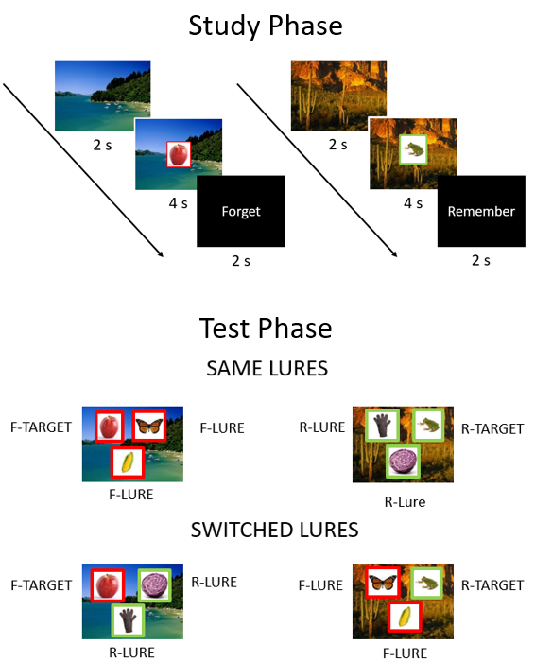

Figure 1. Study design for Experiments 1 and 2. Participants are first presented with object-scene pairings at encoding. Half are followed by a remember instruction, the other half by a forget instruction. At test, participants are presented with three previously studied objects superimposed onto a previously studied scene. One of the objects had previously been paired with the scene (target). Participants are to indicate which object is the target. Lures can come from the same or opposite memory instruction trial as the target. Targets and lures could appear in any of the three test locations equally often. Red and green borders are used here to highlight F and R cued items, respectively, and were not present during the experiment.

Figure 2

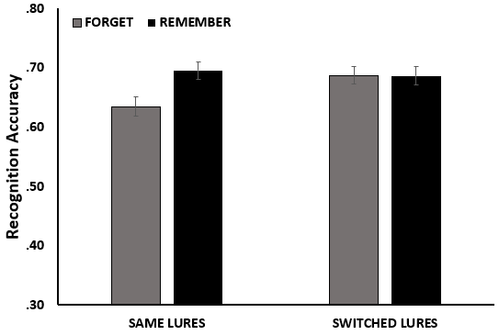

Figure 2. Recognition accuracy in Experiment 1 as a function of DF Instruction and Lures conditions. Performance was calculated by aggregating across trials. The error bars reflect SE of the mean.

Figure 3

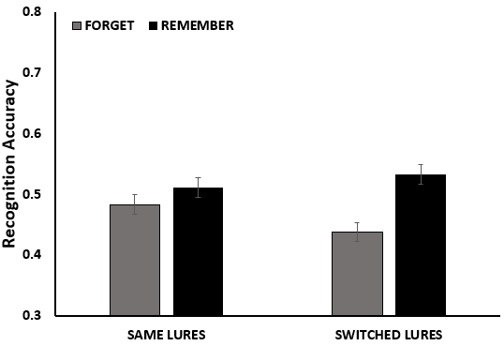

Figure 3. Recognition accuracy in Experiment 2 as a function of DF Instruction and Lures conditions. Performance was calculated by aggregating across trials. The error bars reflect SE of the mean.

Figure 4

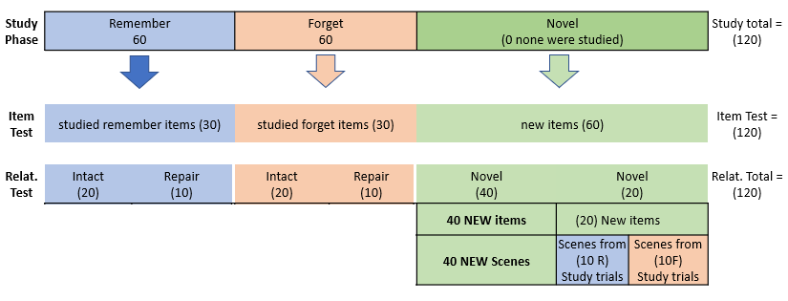
Figure 4. Design and procedures for Experiment 3. Participants are first presented object-scene pairings at encoding, each object followed by a memory instruction to either remember or forget that object. At test, participants are initially presented with either a previously studied or a novel object for a Yes/No item recognition test, immediately followed by an associative recognition test in which they made a judgment regarding whether that same object was studied with a background scene that was either old or new. Old objects were presented with either their originally studied scene (Intact pair), or a scene that was previously presented with another studied object that was given the same memory instruction (Rearranged pair). New objects were presented with either a scene that was previously studied with old objects, equally studied with R and F objects (Novel F-R pairs), or a novel scene (Novel pairs).

Figure 5

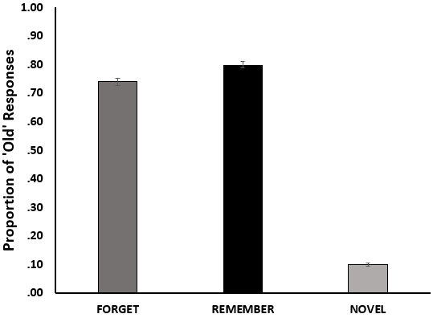
Figure 5. Proportion of ‘Old’ responses in the item recognition task for Experiment 3 as a function of Item Type (Remember vs. Forget vs. Novel). Performance was calculated by aggregating across trials. The error bars reflect SE of the mean.

Figure 6

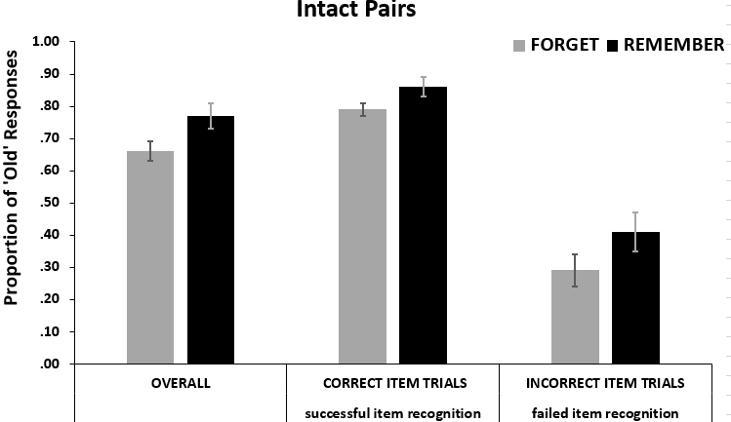

Figure 6. Proportion of ‘Old’ responses for Intact Pairs in Experiment 3 as a function of DF instructions, both overall as well as conditionalized on item accuracy (correct vs. incorrect). Overall accuracy is displayed in the left panel, whereas accuracy conditionalized on correct and incorrect item recognition is shown in the middle and right panel. The error bars reflect SE of the mean.

Figure 7

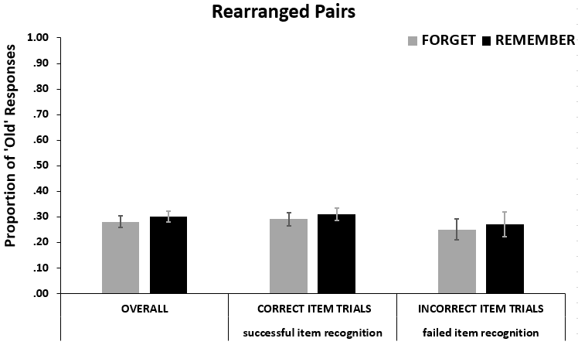
Figure 7. Proportion of ‘Old’ responses for Rearranged Pairs in Experiment 3 as a function of DF instructions, both overall as well as conditionalized on item accuracy (correct vs. incorrect). Overall accuracy is displayed in the left panel, whereas accuracy conditionalized on correct and incorrect item recognition is shown in the middle and right panel. The error bars reflect SE of the mean.

Figure 8

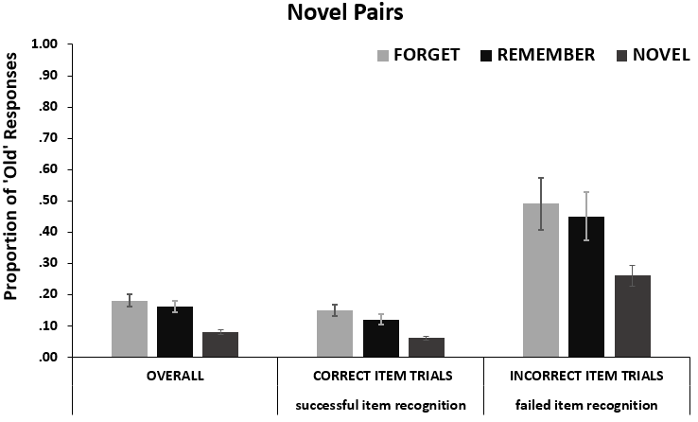
Figure 8. Proportion of ‘Old’ responses for Novel Pairs in Experiment 3 as a function of Item Type, both overall as well as conditionalized on item accuracy (correct vs. incorrect). Overall accuracy is displayed in the left panel, whereas accuracy conditionalized on correct and incorrect item recognition is shown in the middle and right panel. The error bars reflect SE of the mean.

The paradigm is agnostic as to whether the association made between item and its background scene is an item-context or an item-item association.
Confidence judgments were collected for exploratory analyses as they would later go on to inform a series of eye-tracking studies that explored the relationship between subjective memory strengths, as assessed by confidence judgments and eye movement behavior (published in Whitlock, Lo, Chiu, & Sahakyan, 2020).
We initially tested whether random slopes would contribute significantly to our Mixed Logit Regression Model by adding a random slope for the effects of Cue and Lures. Doing so revealed that the model was not improved by including a random slope for the effect of Cue and Lures, Mixture χ²_{2,1}=0.02, p = .935, and therefore no random slopes were included for the effect of Cue or Lures in the final model. The variance associated with the random intercept of participants was σ² =0.75, SD=0.86.
We initially tested whether random slopes would contribute significantly to our Mixed Logit Regression Model by adding a random slope for the effects of Cue and Lures. Doing so revealed the model was significantly improved, Mixture χ²_{2,1} = 11.09, p = .002, indicating the effects of Cue and Lures varied across participants. The variance associated with random effect of participants was σ² > 0.00, SD > 0.00. The variance associated with the random slope of Cue was σ² = 0.04, SD = 0.21, and the variance associated with the random slope of Lures was σ² = 1.15, SD = 1.07.
We first tested for whether a random slope for the fixed effect of Item Type would contribute significantly to the model. Doing so revealed that the model was improved by including a random slope for the effect of Item Type, Mixture χ²_{1,0} = 53.41, p < .001. Therefore, we included a random slope for the fixed effect of Item Type in the model. The variance associated with random intercept for participants was σ² =.73, SD=.76, and the variance associative with the random slope for Item Type was σ² =1.02, SD=1.01.
A likelihood ratio test revealed that including random slopes for the effects of Pair Type, Object Accuracy, and Cue significantly contributed to the model, Mixture χ²_{3,2} =211.22, p < .001, and therefore a random slope for the effects of Pair, Object Accuracy, and Cue were included in the final model. The variance associated with random intercept for participants was σ² =2.75, SD=1.66, the variance associative with the random slope for Cue was σ² =0.17, SD=0.41, the variance associative with the random slope for Pair was σ² =1.45, SD=1.20, the variance associative with the random slope for Object Accuracy was σ² =0.46, SD=0.68.
False-alarm rates for the Novel Pair including both a novel object and a novel scene were minimal (M=0.08, SD=0.27).

